RURAL & MIGRANT MINISTRY (RMM)
SUMMER FELLOWSHIP FOR SEMINARIANS: 2026 APPLICATION

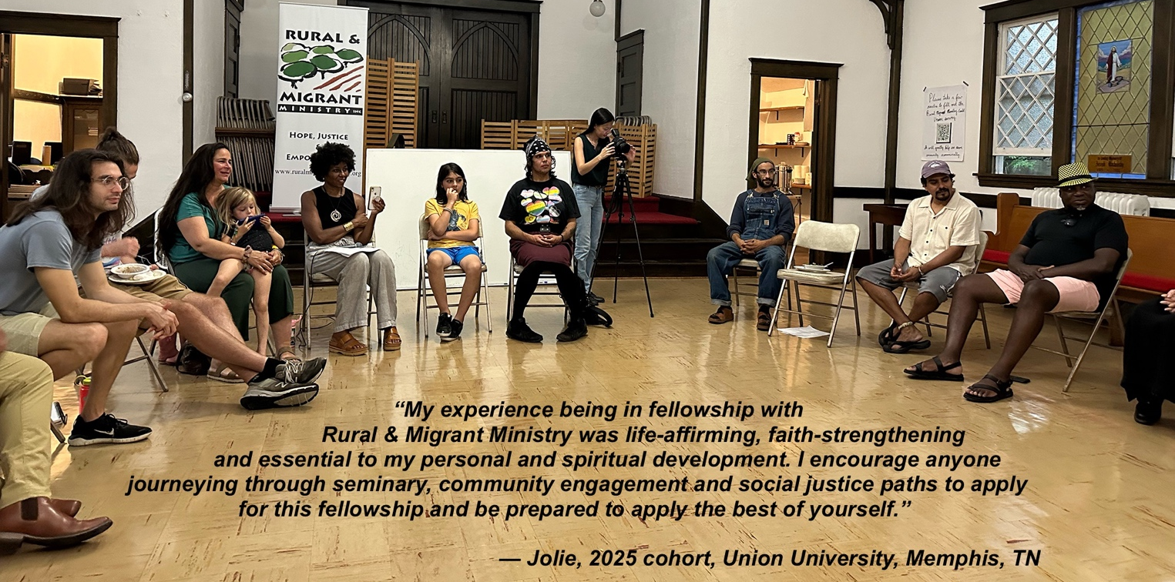

- What experience or gifts do you have that would make you an asset to the RMM Summer Fellowship Learning Community?

- As you reflect on your formation for ministry in Seminary, what learning opportunities do you hope to explore as an RMM Summer Fellow?

- Please tell us about your experience living and/or working in community.

- Please tell us about a time when you demonstrated flexibility in the face of events or situations not going as you anticipated.

- What 2-3 soul questions will you be seeking to answer this summer as an RMM Summer Fellow?

If I am selected to be a 2026 Rural & Migrant Ministry Summer Fellow, I commit to engaging fully and flexibly with all aspects of the program, including my RMM program placement, my congregational setting, our learning cohort, and our living community. I believe that I have the emotional, physical and spiritual health to fulfill this commitment.

Signature Date

Name

Email Phone

Address

Please complete this application by February 2, 2026, and send it to jane.soyster.gould@gmail.com, along with:
- A cover letter detailing the learning goals and vocational passion that inspire you to apply for the RMM Summer Fellowship;
- Your résumé;
- Two references, at least one of which is written by someone who has worked with you; and
- A copy of your Driver’s License (RMM provides vehicles but Fellows will need to drive to placements.)

